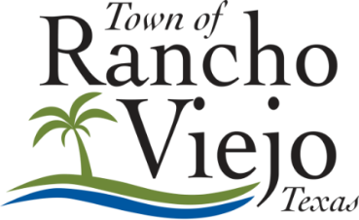

NOTICE OF A PUBLIC MEETING

NOTICE is hereby given of a BUDGET WORKSHOP of the BOARD OF ALDERMEN of the TOWN OF RANCHO VIEJO, TEXAS, to be held on Wednesday, September 16, 2026, at 5:30 P.M., in the TOWN MUNICIPAL OFFICE, 3301 CARMEN AVENUE, RANCHO VIEJO, TEXAS to consider the following items:

Call to Order
- Roll Call

Business Items (Discussion & Action)
- Consideration/ Action on Budget Amendment for FY 25-26- Streets Reserve- Cul-de-sac Phase I and 2018 Streets Project
- Consideration/ Action Lease of 2026 Ford Explorer Pursuit for FY 26-27
- Workshop on Proposed Budget for Fiscal Year October 1, 2026, to September 30, 2027.

Adjournment
- Adjourn

Patty Flores, Town Administrator
Note: Pursuant to Section 551.127, Texas Government Code, any Alderman may attend this meeting remotely using videoconferencing technology. During the portions of the meeting open to the public, the video and audio feed can be viewed and heard by the public at the address posted above as the location of the meeting.

State of Texas
County of Cameron
Town of Rancho Viejo

I, the undersigned authority, do hereby certify that the above NOTICE OF BUDGET WORKSHOP of the Board of Aldermen of the Town of Rancho Viejo, Texas is a true and correct copy of said NOTICE, which has been posted on the window of the Town of Rancho Viejo Municipal Office, 3301 Carmen Avenue, Rancho Viejo, Texas, a place convenient and readily accessible to the General Public, on September 9, 2026, at 4:30 PM and which will be continuously posted for a period of three (3) business days prior to the date and time said meeting was convened.

ATTEST:

Patty Flores, Town Administrator

